**LITERATURE SURVEY**

Smart Fashion recommender application

**Paper Title:** Fashion recommendation systems.

**Publication:** July 2021.

**Author name:** Chakraborty. S, Hoque, M.S, Jeem. N.R, Biswas. M. C, Bardhan. D, Lobaton. E.

**Methodology:** Content-Based Filtering (CBF) Technique

The content-based filtering (CBF) technique examines the features of a recommended item by classifying users (or consumers) and products profile data based on the product features. The use of domain-dependent algorithms emphasizes the analysis of the product’s features, which are utilized to generate predictions. Although the applications of content-based filtering techniques have been more successful in recommending web pages, publications, and news articles, researchers have implemented this technique to develop a fashion recommendation system as well. In this technique, user profiles are matched with the features extracted from the product content, which provides the recommendation where the user has evaluated a specific product in the past. The products that have the highest relationship with the positively scored or rated items are generally recommended to users. The content-based technique different kinds of models to explore the similarity between items to generate a meaningful recommendation, which is the main distinctive feature of content-based and collaborative filtering techniques. These machine-learning techniques propose recommendations by learning the core or foundations of the underlying model. In this type of filtering the rating of an item is calculated based on the other ratings. Figure shows a bipartite graph generated from the user interaction, where the orange shirt will receive a rating for user 1 because the other 2 reviews about that shirt both gave it 5 stars. This method of filtering is used when the target user is not known and much about the apparel to be sold is known. Here, the directed edges from the users to the items represent users interaction with the items through likes, comments, retweets, etc

Researchers have used probabilistic models such as the Bayesian classifier, decision tree and neural network model to develop content-based recommendation systems. CBF does not require profiles of other users as it can adjust its recommendations within a short period even if the user’s profile changes. Viriato de developed a recommendation system based on a combination of textual features, visual attributes and visual attention using a content-based filtering technique. Their proposed model, named CRESA (Clothing Recommendation System developed using Attributes such as textual attributes, visual features, and visual attention), outperformed standard models such as the k-nearest neighbor (kNN) model. It achieved an average precision of 74.8%, which was better than the other standard models. Wu et al. also adopted a similar approach of providing fashion recommendations based on the visual and textual information provided by the users.

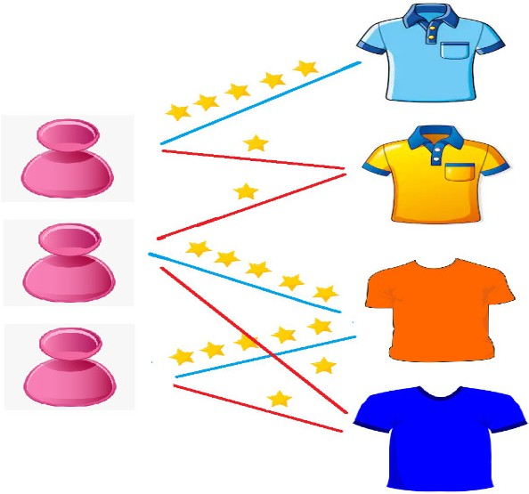

**Paper Title:** A COMPREHENSIVE REVIEW ON ONLINE FASHION RECOMMENDATION

**Publication:** December 2020

**Author name:** Samit Chakraborty

**Methodology:** Auto Regression (AR) and Linear Regression Model.

Auto Regression (AR) and Linear Regression Model.

(Ngai et al., 2018) used the autoregressive (AR) model (or ARMAX) for predicting style or trends using the images retrieved from social media, online fashion magazines, popular e-commerce, fashion site blogs, and discussion forums. It facilitates accurate prediction of trends as the data patterns are retrieved over a certain period (Fung, Wong, Ho, & Mignolet, 2003). Two distinct studies by Liu et al., (2013) and Nenni, Giustiniano, & Pirolo (2013) showed that the theoretical contents of these forecasting models in depth and discussed the various forms of general approaches. Statistical methods like auto-regression, exponential smoothing, ARIMA, and SARIMA were commonly used to evaluate fashion sales because they were simple, fast, well-informed, and easy to comprehend. Demiriz (2018) suggested a system in which retail goods can be forecast weekly by linear regression models in multi-processing groups that contain both positive and negative goods. Dynamic pricing models have been then used to validate markdown decisions in multi-item group forecasts. Grouping objects in predictive models may be viewed as a method of variable selection to avoid overfitting. Besides the findings from the single-item regression model, they then displayed regression results from multiple-item groupings on the real-world dataset given by a clothes retailer. In addition, they then reported markdown optimization outcomes for single items and groupings of multi-items on which multi-item forecasting models are based. In contrast to the one-item model, the findings suggested that the regression models offer better estimates in multiple groupings.

**Paper title:** Fashion Evaluation Method for Clothing Recommendation Based on Weak Appearance Feature

**Publication:**  Year(2017).

**Author Name:** Xiang Liu.

**Methodology:**  Utility-Based Recommendation.

First of all image database is established and three aspects of appearance weak features are put forward to characterize the fashion level. Furthermore, the appearance of weak features is extracted according to the character’s facial feature localization method. Last but not least, consumer fashion levels can be classified through support vector products, and the classification is verified with the hierarchical analysis method.

The experimental results show that consumers fashion level can be accurately described based on the indexes of appearance weak features and the approach has a higher application value for the clothing recommendation system.

**From the review of the related literature, the following conclusions can be drawn.**

The retrieval means of customer data are of importance. In the past, businessmen would retrieve customers data through membership cards and questionnaires. Such a method fails to guarantee the authenticity of data since the data could not be timely upgraded in case of any physiological and psychological changes in customers. At present, e-commerce businessmen mainly make recommendations through registering virtual members, tracking consumption, and browsing information. However, the recommendation results are sometimes not ideal, since some customers doubt if their private information will be exposed. Confronted by the difficulty in data retrieval, this paper utilizes the camera as the output equipment of image and video to retrieve customers data. After building the image database and analyzing the image data, this paper subsequently classifies customers according to their fashion level. This classification will be upgraded with the change in customers data. In the end, garment recommendation will become easy according to customers classification data and clothing classification data.

The recommendation method based on customer rating and personal interests, to some extent, has backward features. In practical conditions, most customers would judge the vogue of clothing according to their subjective feelings and matching degree. In particular, most people will become confused when selecting clothes. It is the representation of customers’ ambiguity regarding their conditions.

As for the recommendation method based on the contents, it is applicable for multiple regions. Typically, it will recommend new projects to users according to their browsing records. The recommendation results have been proven to be explicit and accessible. The utility-based recommendation. For instance, Scholz et al. (2015) found that exponential utility functions are better geared to predicting optimal recommendation ranks for products, and linear utility functions perform much better in estimating customers’ willingness.

**Paper Title**: A Review of Modern Fashion Recommender Systems.

**Publication**: December 2021.

**Authors Name**: Yashar Deldjoo, Fatemeh Nazary, Arnau Ramisa, Julian McAuley, Giovanni Pellegrini, Alejandra Bellogin, and Tommaso Di Noia.

**Methodology**: Convolutional Neural Network.

Different types of visual explanations used for fashion recommendation are illustrated. Chen et al. present a method that provides visual explanations to the user through certain regions of the items, where an combines visual information and user reviews. With the same goal, Tangseng and Okatani propose a system Long Short-Term Memory that provides outfit recommendations and provides scores for each item or for each item feature to understand how much these influence the outfit composition. To explain whether an item/feature is compatible with the outfit and its influence on the score, three attributes have been extracted from the images: shape, texture, and colors. K-means clustering is applied for colors, and a Convolutional Neural Network is used for shape and texture representation.

Fashion recommendations can be improved using image-level features extracted through a deep network, such as a Convolutional Neural Network. For instance, Zhou et al. propose a Convolutional Neural Network implementation to address the issue of two-piece apparel matching that is suitable with current fashion trends. They merged perception and reasoning models and constructed two parallel Convolutional Neural Networks to enable the system to recognize garment features, one for upper-body clothing and another for lower-body apparel. A hierarchical topic model incorporates the resulting information into style topics with better semantic understanding to interpret the collocation patterns. The authors present a novel learning model based on Siamese Convolutional Neural Networks (SCNN) for learning a feature transformation from clothing photos to a latent feature space expressing fashion style consistency.

**Paper Title:** Image-based fashion recommender system.

**Publication:**  Year (2021).

**Author name:** Shaghayegh Shirkhani

**Methodology:** Filter method, Iterative approach, Matrix factorization, content-based system, collaborative filtering.

Collaborative filtering systems recommend items based on similarity measures between users and/or items through clustering products bought from similar users.Collaborative filtering systems have many forms, but many common systems can be reduced to two steps:

1. Look for users who share the same rating patterns as the active user (the user whom the prediction is for).
2. Use the ratings from those like-minded users found in step 1 to calculate a prediction for the active user.